Phantom – Ghost Theme Documentation

Theme : Phantom

Version: 1.0

Compatibility : Ghost 0.4.x

# Installing the theme

After unzipping the theme folder place it in content/themes/

content/themes/phantom

To switch to your newly added theme:

Restart Ghost. At the moment, Ghost won’t notice that you’ve added a new folder to content/themes so you’ll need to restart it  
Login to your Ghost admin, and navigate to /ghost/settings/general/  
Select your Theme name in the ‘Theme’ options dropdown  
Click ‘Save’  
Visit the frontend of your blog and marvel at the new theme.

# Blog Settings

Login in your ghost backend (domain/ghost) and go to the **Settings>general**  
These are the Blog specific settings.

1. Blog Title: Changes your Blog’s title.
2. Blog Description: Changes your Blog’s description. Theme reference @blog.description.
3. Blog Logo: Upload a Logo for your blog in either ‘.png’, ‘.jpg’ or ‘.gif’. Theme reference @blog.logo.
4. Blog Cover: Upload your blog cover image in either ‘.png’, ‘.jpg’ or ‘.gif’. Theme reference @blog.cover.
5. Email Address: This is the email admin notifications are sent too. It must be a valid email.
6. Posts per page: This is how many posts are displayed per page. This should be a numeric value.
7. Theme: This will list all the themes in your content/themes directory. Selecting one from the dropdown will change your blog’s look.

# Top Navigation Menu

Navigation Menus are created using the Ghost 0.4 static page feature. So, actually we are linking the static page to Navigation Menu.

This theme has 3 prebuild menu item with following URL—

About — /about

Features — /features

Contact — /contact

To enable a Menu, you have to create a static Page by just checking “Static Page” option and giving the appropriate URL that defined on theme like below :

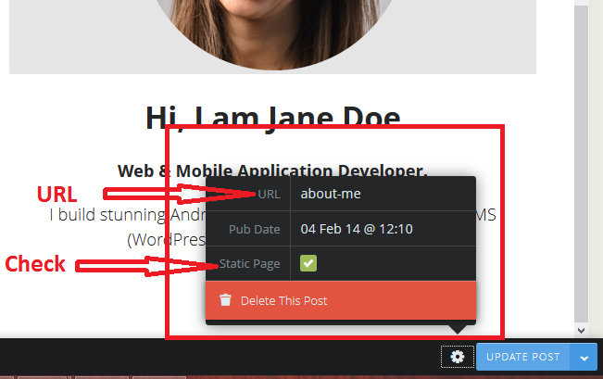

# Changing URL from theme

If you want to change the predefined Page URL, then you have to edit from theme.

Open your index.hbs file and find the section commented with {{! Top Toggle Menu}}”

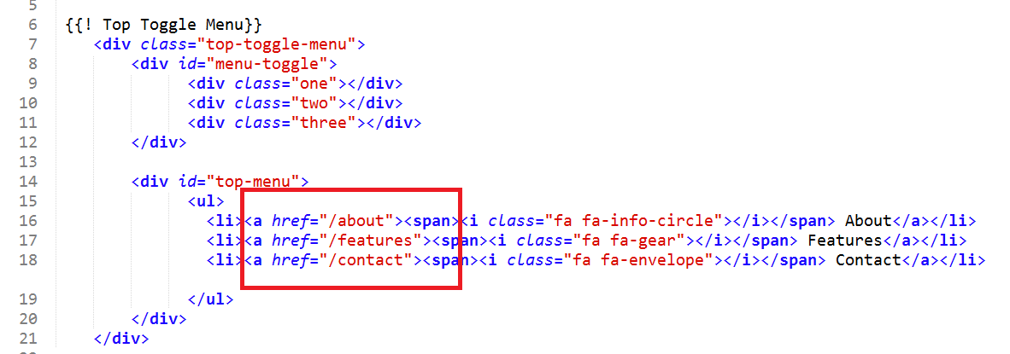

Change the URL and Menu item name to your desired names and create static page with the same URL. That’s it!

# Changing Social Icons and Links

There are two social icon sections on this theme. One is on the Home Landing Page and other one is on the footer of left sidebar.

#### For Home Page Center

To change the social icons and their links you have to open the index.hbs file and find the section commented with “{{! Social Icons}}”.

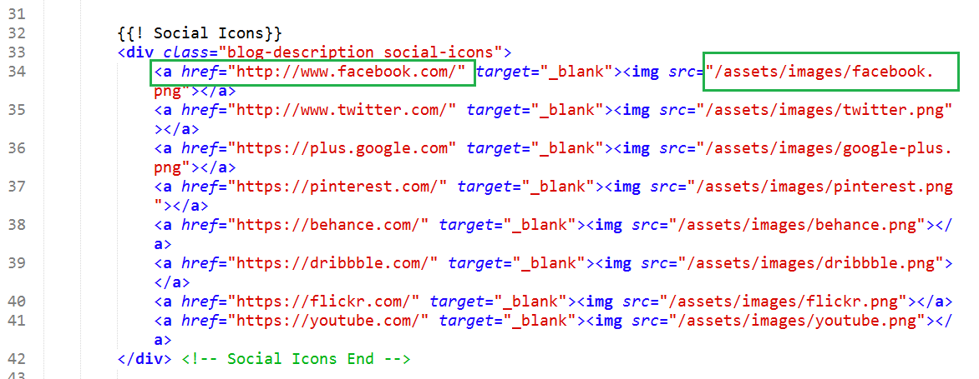

Now change the links and associated icon (image link).

#### Sidebar Social Icon

To change the social icon and link you have to open the index.hbs file and find the section commented with “{{! Footer Social Menu }}”

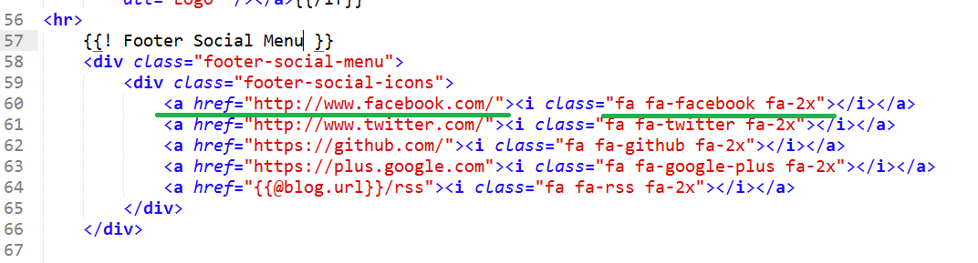

Now change the link and icon class. Icons are placed using [Font Awesome Icons](http://fontawesome.io/icons/). Go to their website and find hundreds of icons - <http://fontawesome.io/icons/>

You need to change the social icons from post.hbs and page.hbs too. Just find out the section commented with “{{! Social Menu }}” and change your link and icon.

# Placing Content to Sidebar

There are two different sidebars for Page and Post. We placed a Facebook like box on Post Page and Static Page sidebar is empty. You can place your any HTML content there.

post.hbs

Open post.hbs Find the section commented with “{{! Post Sidebar }}”

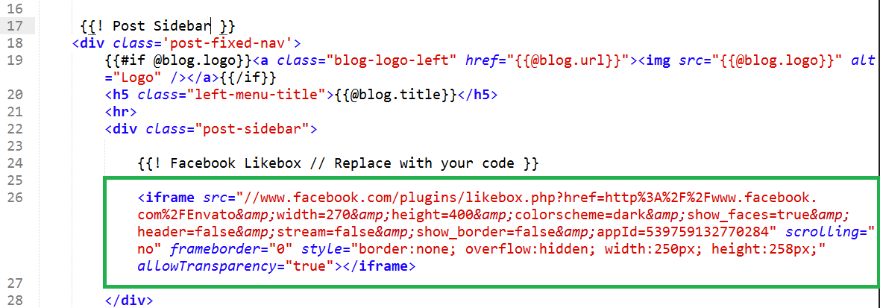

You will find the Facebook Like box code. Replace it with your own code.

You can create Like box code for your own page from [here](https://developers.facebook.com/docs/plugins/like-box-for-pages/) —

<https://developers.facebook.com/docs/plugins/like-box-for-pages/>

# Creating Page/Post

Creating Pages and posts are pretty easy. From your dashboard just click “+New Post” and check the “Static Page” for Pages. For Posts you don’t need to click it.

The difference of Post and Page is Posts are Posts will be on Homepage where Page will be only linked through Menu or Posts.

# Integrating Disqus Comment

To enable disqus comment you have to replace your disqus code from post.hbs . Find the section commented with “{{! Discuss Comment Integration}}” and replace with your code. You will have to create a disqus account from their website : disqus.com

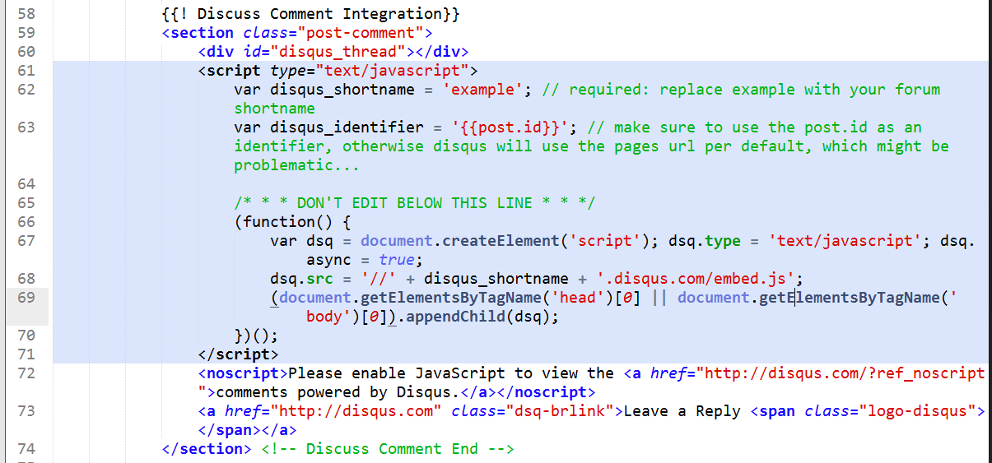

Here is a good write up for more details.

http://blog.christophvoigt.com/enable-comments-on-ghost-with-disqus/

# Dummy Content

We used some content in pages and posts (like soundcloud embedding, vimeo embedding). These are nothing complex at all. Just place your embed code to post editor. It will work fine.

### Soundcloud Example :

<iframe width="100%" height="300" scrolling="no" frameborder="no" src="https://w.soundcloud.com/player/?url=https%3A//api.soundcloud.com/tracks/118951274&amp;auto_play=false&amp;hide_related=false&amp;visual=true"></iframe>

(You will find it on soundcloud website when click “Embed”)

### Skill Page Example

<center>

<i style="color:#ED5E26" class="fa fa-html5 fa-3x"></i>

**HTML5 Expert**

<i style="color:#0171BB" class="fa fa-css3 fa-3x"></i>

**CSS3 Ninja**

<i style="color:#A5C63B" class="fa fa-android fa-3x"></i>

**Android Lover**

<i style="color:#7F9BB3" class="fa fa-apple fa-3x"></i>

**iOS Enthusiast**

<i style="color:#26CAED" class="fa fa-windows fa-3x"></i>

**Windows Developer**

</center>

Icons are from Font Awesome with some custom color

If you find any problem or need support for the theme feel free to shoot us at [support@codetic.net](mailto:support@codetic.net)

Thanks